

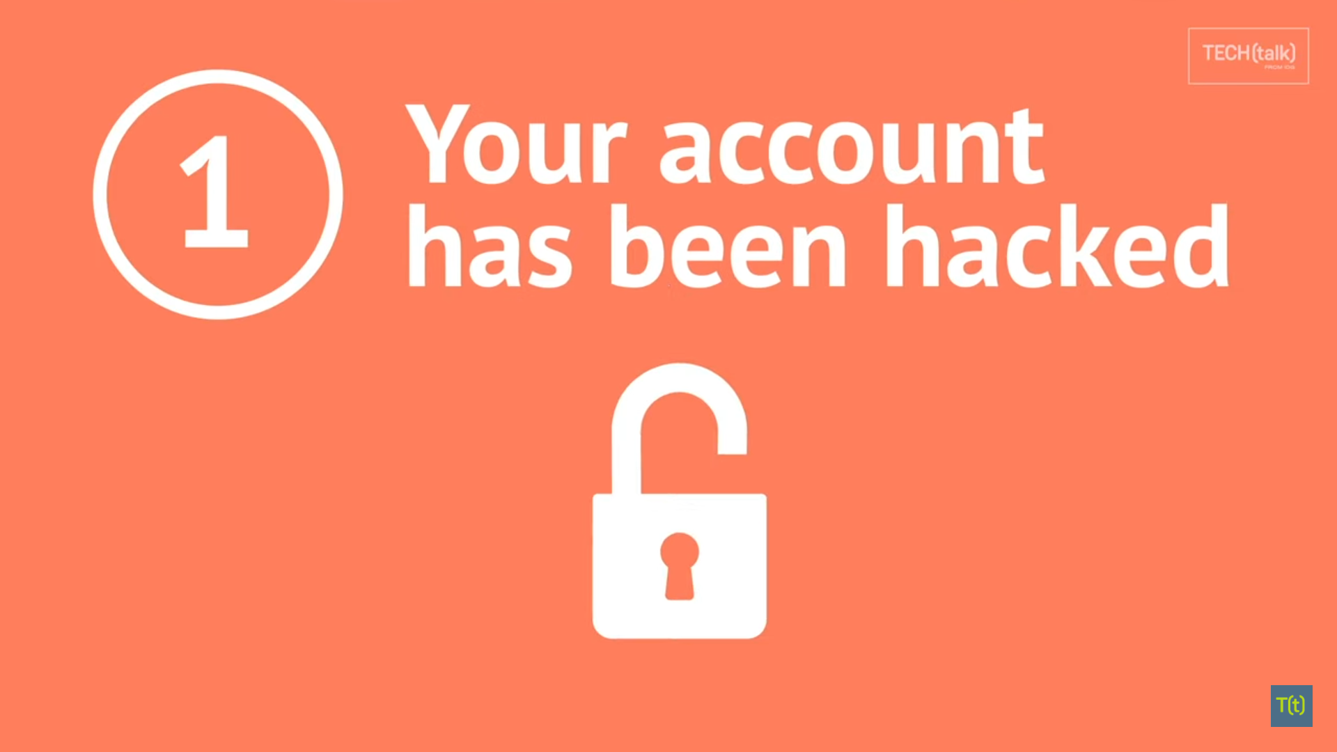

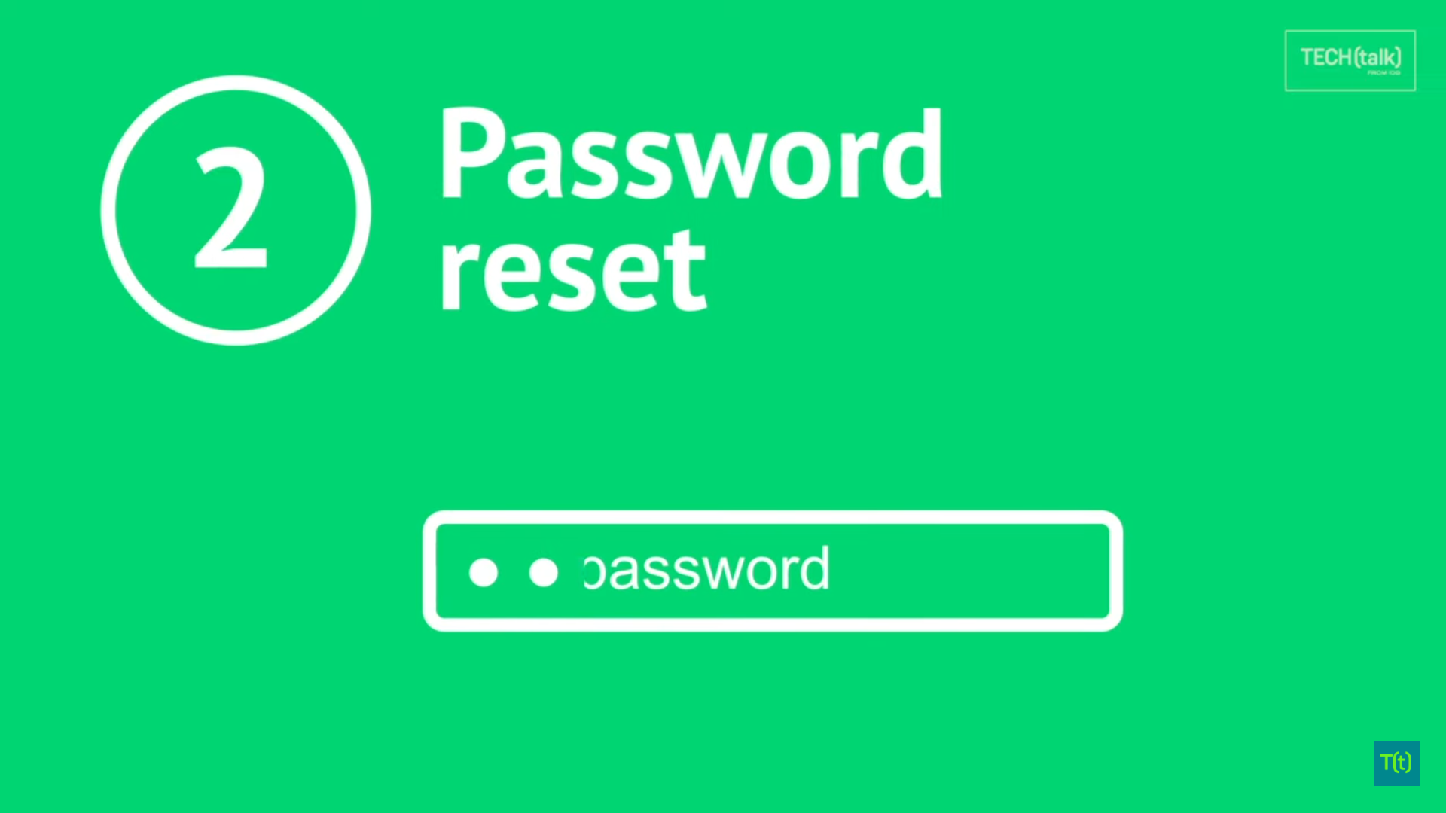



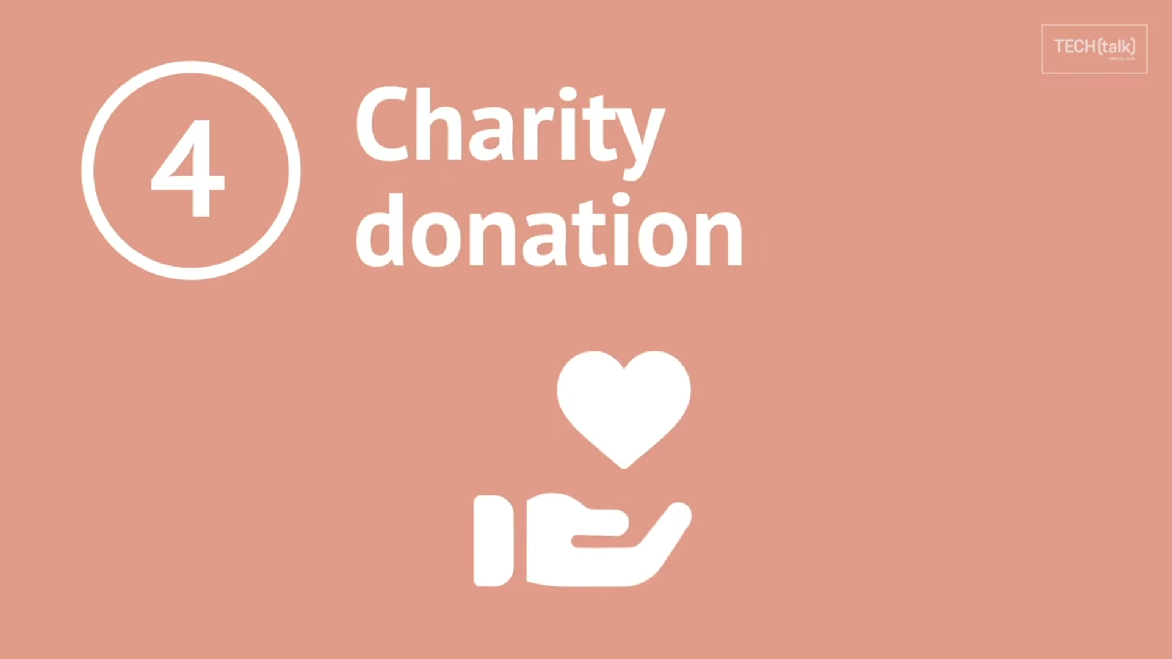

**Introduction to Phishing**:

* Define what phishing is and provide a brief overview of its significance in cybersecurity.

Phishing – Form of Cyber attack

**Types of Phishing**:

* Explore different types of phishing attacks, such as:
  + **Email Phishing**: Explain how attackers use deceptive emails to trick recipients.
  + **Spear Phishing**: Discuss targeted phishing attacks on specific individuals or organizations.
  + **Pharming**: Explain how attackers manipulate DNS to redirect users to fraudulent websites.
  + **Vishing**: Describe voice-based phishing attacks over the phone.
  + **Smishing**: Discuss phishing attacks through text messages (SMS).

**Phishing Techniques**: (Provide images)

Detail common techniques employed by phishers, such as:

* + **Spoofed Websites**: Explain how attackers create fake websites that mimic legitimate ones.
  + **Social Engineering**: Discuss the psychological manipulation used to deceive victims.
  + **Malware Distribution**: Explain how phishing emails often contain malicious attachments or links.

**Phishing Indicators**:

* Teach readers how to recognize phishing attempts by identifying red flags like:
  + Suspicious email senders.
  + Generic greetings.
  + Urgent or threatening language.
  + Requests for sensitive information.

**Prevention and Protection:**

* **Offer tips and strategies to prevent falling victim to phishing attacks, including:**
  + **Using email filtering systems.**
  + **Verifying URLs and sender information.**
  + **Educating employees and individuals.**
  + **Keeping software and antivirus programs up to date.**

**Phishing Targets+ Impact of Phishing:**

Discuss who phishers target, such as individuals, businesses, or government organizations.

Explain the financial and reputational damage caused by successful phishing attacks.

**Technological Solutions**:

* Explore advanced technologies and tools used to detect and mitigate phishing attacks, such as machine learning and artificial intelligence.

**Conclusion**:

* Summarize the key takeaways and emphasize the importance of vigilance and proactive measures against phishing.